**Final Report Catalog**

**Problem Background**

* Persona Portrait
* Persona’s Problem
* Problem Statement

**Requirements**

* Info requirements
* Sources of required info
* Shortcomings

1. *Fragmented Info*:
2. *Incorrect Info*:
3. *Missing information*:

* Remedy Strategy

**Business Sustainability**

* Business Potentials
* Business Mechanism
* Business Revenue
* Adoption of Membership
* Potential Competitors
* Interviews of Supply-Side

**Design**

* Information Architecture
* Navigation Design
* Information Layout Design

**Test/Evaluation**

* Usability

1. *Test objectivities*
2. *Tasks of tests*
3. *Usability Test reports*
4. *Design Revision*

* Google Tracking

1. *Google Optimize A/B tests results*
2. *Google Analytics Page Views*
3. *Google tag manager – Event tracking*

* Database Registered Users
* Recommendations (Market Studies & Further development)

1. *Attractive Content*
2. *User Community*
3. *Redo Google Test*
4. *Explore potential business sustainability*

**Final Report**

The project is street dancing web in Hong Kong, providing dancing resources and info to audiences. To report how the project was processed from zero to one, the following report will discuss five main sessions: problem background, requirements, business sustainability, design, and test/evaluation.

**Problem background**

Before getting started, the project looked over who would be the potential persona of the site. It noticed that students made up the majority of the dancers. Thus, the project decided to set students as the persona. To further specify the persona, the project finally located the persona as university students who are keen on street dancing. Based on the interviews of the persona, several characteristics of them are summarized.

Persona Portrait

1. Some expertise on dance: most of them already have danced for a few years.

2. Sufficient sustainability and passion for dancing: Compared with dance novices, they regard street dancing not just as a hobby anymore, but attitudes, psychological release, and Spiritual sublimation. In other words, dance is already in their blood, and they have a sustainable passion for street dancing.

3. Clear Dance Preference: Since they are not freshmen on dancing, they have a clearer preference for their dance styles and tastes. They are teacher-driven, following their favorite teachers to have classes instead of staying at one studio.

4. Info searching tool: They use IG to search for information.

5. Daily routine: Even though they are busy with school and study, they maintain to spend at least 10 hours a week on dancing, taking 3-4 dance classes a week.

6. Clear Dance Goal: They see dance as a potential career in the future, wanting to be a professor dancer. They are eager to improve dance competence through practice, workshops, and competitions. They are dance improvement info hunger.

7. Considerable consumption of dancing: They are big fans of dancing accessories. Most of their clothing consumption is buying dancing T-shirts. Most of them reflected that they usually buy one shirt a month, attend 1-2 workshops per semester, participate in 1-2 competitions per month. They roughly spend 2300 HKD a month on dancing. (See Figure 1).

Problem background

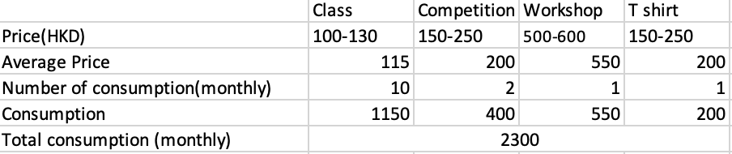

Figure1. Roughly spending on dancing each month

Persona’s Problem

According to the interview, they reported different extents of difficulties getting the complete info of street dancing industry in Hong Kong. They wonder where their favorite teachers would take classes for dance classes information. They spend time viewing and searching teachers’ IGs one by one and seeing whether the teachers’ dancing styles fit what they like. If yes, they move to the next level of searching, seeking what studios the teachers take classes, by looking at the studio IGs. The entire process of finding classes is time-consuming and desperate. In sum, the problem can be defined as a lack of info integration.

They are interested in class info, but they also look for dance improvement resources and dancing clothing. For workshops, competitions, and accessories, the persona heavily relies on word of mouth on IG forwarded stories to know the info. They reported that seeing the information is made by chance. If the persona sees the forwarded stories, she/he accesses the messages. If not, he/she misses. The persona students do not know who the original author of the posts is, which means that they have no idea of the source of information. In this way, the info problem cannot just regard as integration like the previous one, but also the failure to access because of unknowing.

Problem Statement

How might we help a student(who)who regard street dance as an important part of life and is keen on dancing to address the problem of having troubles integrating and obtaining dance resources(what) to achieve the goal of enhancing dancing and being a professional dancer in the future(why).

**Requirements**

Info requirements

Based on the persona’s pain point on dancing info searching, the project identified three main types of dancing info they are most interested in. They are dance classes based on teachers’ dance class schedules, dance improvement resources (workshops and competitions), and dance accessories.

Sources of required info

For sources of dance classes info, they are from studios’ IGs and teacher’s IGs. There are a few websites of dance recommendations, integrating studio info but only location without dance class schedules. For sources of competitions, workshops, and accessories, they all have their own IG. In sum, the IG following will be the source of info.

Shortcomings

The study tried to do data scraping on the sources but found out several shortcomings.

*Fragmented Info*: By scraping the studio’s IG, we only know multiple teachers’ dance class schedules in one specific studio, but we don’t know the teachers’ other dance class schedules since teachers teach classes at different studios (See Figure 2). By scraping the teacher’s IG, we know the entire dance class schedule of the teacher, but on the contrary, we miss other teachers’ dance class schedules (See Figure 3). In sum, the two sources are with different information architectures. The former is across teachers, and the latter is across studios. Moreover, they are all self-served. We only can scrap info relative with themselves on these IGs.

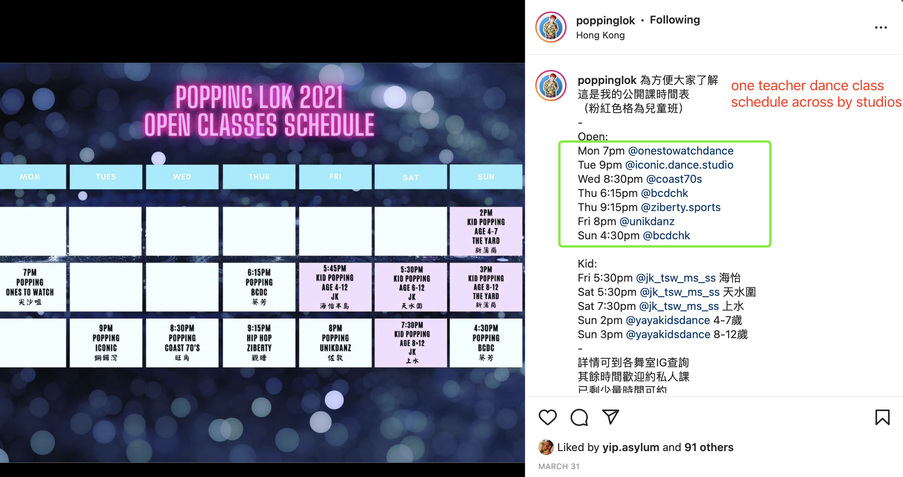

Figure 2. A teacher’s IG regard his dance class schedule

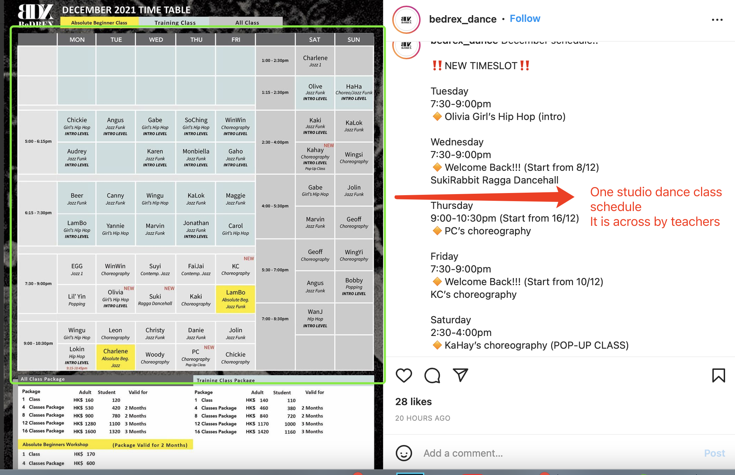

Figure 3. A Studio’s IG regarding its dance class schedule

*Incorrect Info*: By scraping the dance recommendation dance website, hellotoby, it doesn’t include the correct information the persona is looking for. The website is a mixture of fitness studios (roughly 80%), ballet, Latin dance, and children's dance institutions (roughly 10%), and street dancing studios (roughly 10%) (See Figure 4). In fact, the persona is looking for street dancing.

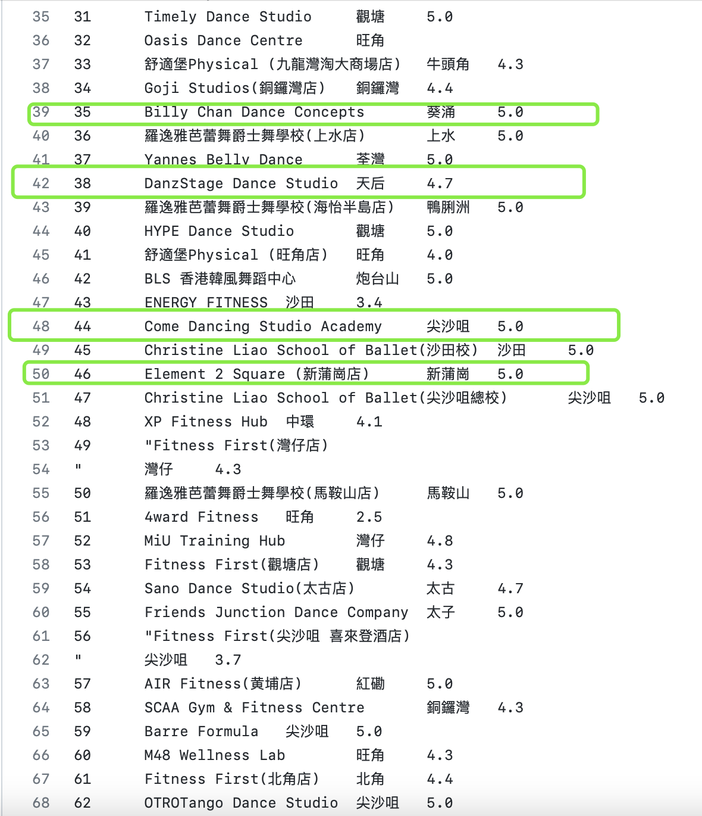

Figure 4. Data scraping results of hellotoby. Green boxes are street dance studios.

*Missing information*: it is hard to scrap competitions, workshops, and accessories info on IG. Must be obtained by one-by-one IG following.

Remedy Strategy

The project found out that data scrap does not work that much on data collection, so that it decided to give up to use data scraped from the third party websites, and the best way would be manual collection. It is time-consuming, but it is more precise. Following multiply teacher IGs and studio IGs to integrate the dance class schedule info across teachers and studios, and following IGs to competitions, workshops, and accessories to obtain the information including name, location, time, fee, and other relative details might be the optimal solution.

**Business Sustainability**

Business potentials

The project did feel hard to look for business potentials instead of making as a hobby website at the beginning. It initially intended to serve dance studios to make money. At the same time, it found that big studios did not even need the website since the popularity of dance studios is even more significant than the website. Therefore, the project started to seek a new target to make profits. The project revised that the suppliers of info that persona requires were not dance studios. Instead, the supply side is small dance businesses such as the holders of competition and workshops, and accessories makers. They heavily rely on word of mouth in IG posts and their official IGs to do their business. According to the previous interview from persona, they did not know the IG of these small businesses, which means there is a lack of connection between the demand-side persona and supply side. These small dance businesses do not have enough exposure and promotion. Thus, the project thinks that providing exposure for these businesses makes revenue. Moreover, based on the previous persona portrait, these student dancers have great consumption abilities on dancing. Thus, the business potentials may be feasible.

Business Mechanism

The website works as a bridge between the supply and demand sides(persona). The website provides exposure for the small dance businesses to increase sales by posting their events on the website. On the other side, the persona can obtain the dance info from the supply side through the website. In this way, it makes both sides happy.

Business Revenue

The website intends to use referrals by charging the supply side specific percentages of each deal made by the website. The project initially came out with a question: How do I know which orders are made via the website instead of the official IG of the supply side? The project went to deep research. It noticed that these small dance businesses use bank transactions, Payme, and FPS to transfer money to the private account as payment methods. After the consumers transfer the money, they are required to fill a google form to leave personal info, order details, and screenshots of the transaction. To track which orders are made via the website, the project came out with an idea by making discount codes. Only people from the website have the codes and apply the code when consuming. In this way, the supply-side may know how many deals are made via the web to count the number of sales and calculate the total referral. Moreover, the website will redirect users to the IG post links of the events and google forms for the payment. No monetary transaction is made on the website. The project also thinks of offering paid ads as another way for promotion by fixed charging 300-500 hkd for one post.

Adoption of Membership

The website also intends to use a membership system for benefits for sustainability and operations of the website. For accessing the discount codes, the users would be asked to register on the website and become members. After registering and logging in, members can access all the exclusive deals. Except for the codes, the content display maintains the same for unregistered users and members. The reason for doing the membership comes out with several benefits. First, it is to keep user personal data. When registering, the website records the name and email of the user. Having the data is better for future business promotion, such as email subscriptions or exclusive content for members. Second, why made distinguishment between unregistered users and members? People will not register if there is a free lunch, doing nothing to get the codes. For stimulating more people to register, the distinguishment is made to let more people recognize the priority of being a member and the benefits of exclusive deals. Third, it can be the persuasion by showing to supply-side how many registered users of the website to increase the credibility. “The website is a good place for promotion and business cooperation.” Fourth, it could better help the supply side to manage the sales operation. If everyone can get the codes, their systems might crush. Discount quotas should be limited to be exposed.

Potential Competitors

To test the possibility of the business model, the project investigates the potential competitors in the market. Luckily, the project hasn’t discovered competitors making one-stop dancing info as the website does yet. Thus, the project might consider alternative potential competitors who might hinder people from adopting the website. The biggest competitors might be studios and teachers’ IG accounts. However, the biggest problem of them is self-served. They only post their own dance class schedules, and no other studios or teachers’ dance class schedules can be acquired. Another competitor might be a dance recommendation website such as hellotoby, but its content doesn’t target the persona well because 90% is about fitness studios and other dances instead of street dancing. In short, the website might surpass due to the info integration and preciseness.

Interviews of Supply-Side

Since the business model is the stage of the proposal, the project did ask several small dance businesses to evaluate whether it has business potentials. One private workshop holder and one competition holder accepted the interview, but other holders were unwilling to do it. They reported that the referral concept to make revenue was good. It was suitable for them not to invest a lot in the earlier stage of promotion, and it was even better than just asking money for a spot or paid ad but without seeing any return at the beginning. They felt less risky to do referral because it was made by the number of sales via the website, and the membership system allowed them to see how much traffics the website brings to them. However, they doubted the amount of traffic and sales the website can get to them since the web was brand-new to the dancers. How does the website increase awareness and promote itself? That will be a question for the marketing after publishing the website. In other words, if holders can see big traffics on the website, they are willing to do so. The other concern is about the percentage of referrals. They were hard to decide due to no previous reference. They roughly said 3-5% of each deal. In shorts, the referral and membership ideas were acknowledged by some of the holders. Overall, the business sustainability survives.

**Design**

Information Architecture

Based on the info requirement of persona, the projects identified three main categories of dancing info in the previous session. They are dance classes, dance improvement resources (workshops and competitions), and dance accessories. However, the project found out these three names were too long to lose the simplicity of the website. It decided to break down dance improvement resources into two categories: workshop and competition. Lastly, the website decided to set and name four types of info: Dance, Workshop, Competition, and Shop. This is the first-class information architecture of the website. The “Dance” is categorized by dance type. There are six types of street dancing: breaking, hip hop, popping, locking, jazz, and waacking. After choosing the dance type, all teacher profiles of the selected dance type can be viewed. The “competition,” “workshop”, and “shop” do not have subsections like “Dance”. All the relative events are displayed after clicking (See Figure 5).

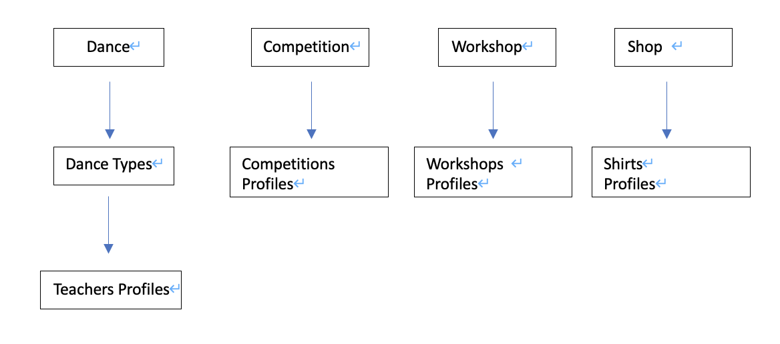

Figure 5. Information Architecture.

Navigation Design

The navigation design on Figma initially came out a long list: Alwaysonbeat, About us, Contact Us, Login, Sign Up, Dance, Competitions, Workshops, Shop, and Log out. Alwaysonbeat is the website's name, and it is the about us page as well. To save the navigation bar space, the project tried to combine the home page and the about us page into one page. The about us page contains home page contents (sign up and brief intro) and about us (website intro). Therefore, the website's landing page is about us (See Figure 6). Also, the project named the dance class "Dance" as initially.

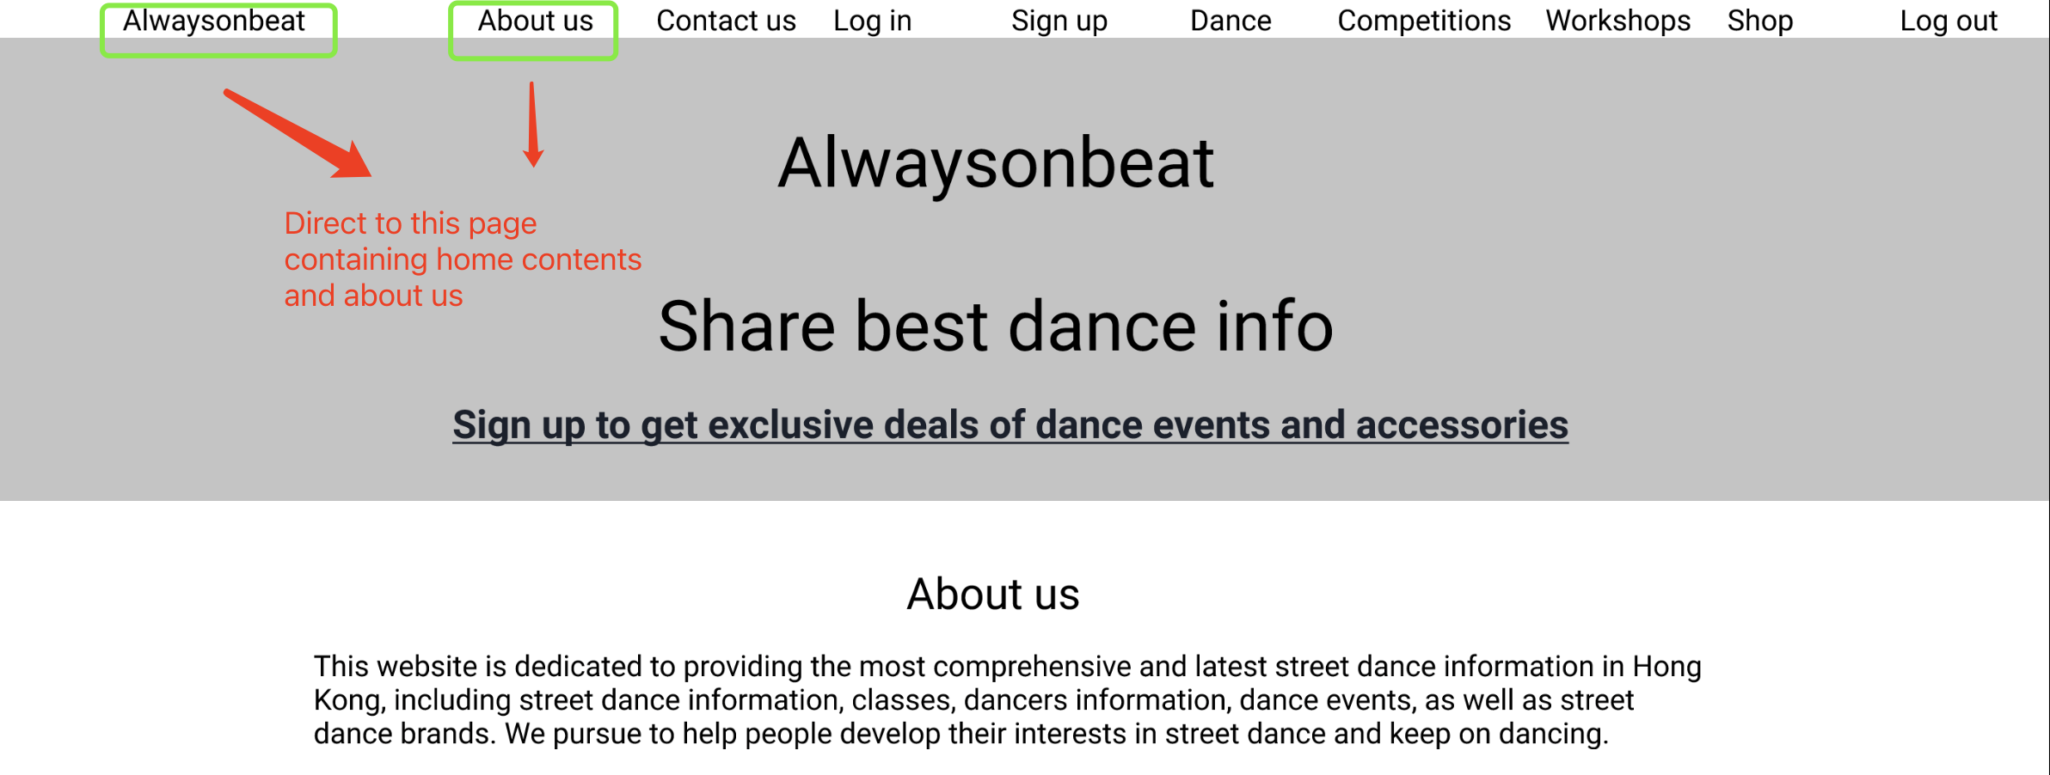

Figure 6. Figma Navigation Design

Information Layout Design

For dance info, six boxes representing dance types were made. After being chosen, each teacher profile can be seen, including the picture, name, IG, the teacher’s dance class schedule across studios he/she teaches. (See Figure 7). For the competition, workshop, shop, they follow the same layout. A poster is on the left, and relative info is on the right. The social media link and registration button would redirect users to the corresponded pages of supplier side. (See Figure 8). For people who do not log in, discount codes will be unavailable, by showing the log in link to encourage them. For people who log in, the discount codes will be displayed and replace the log in link.

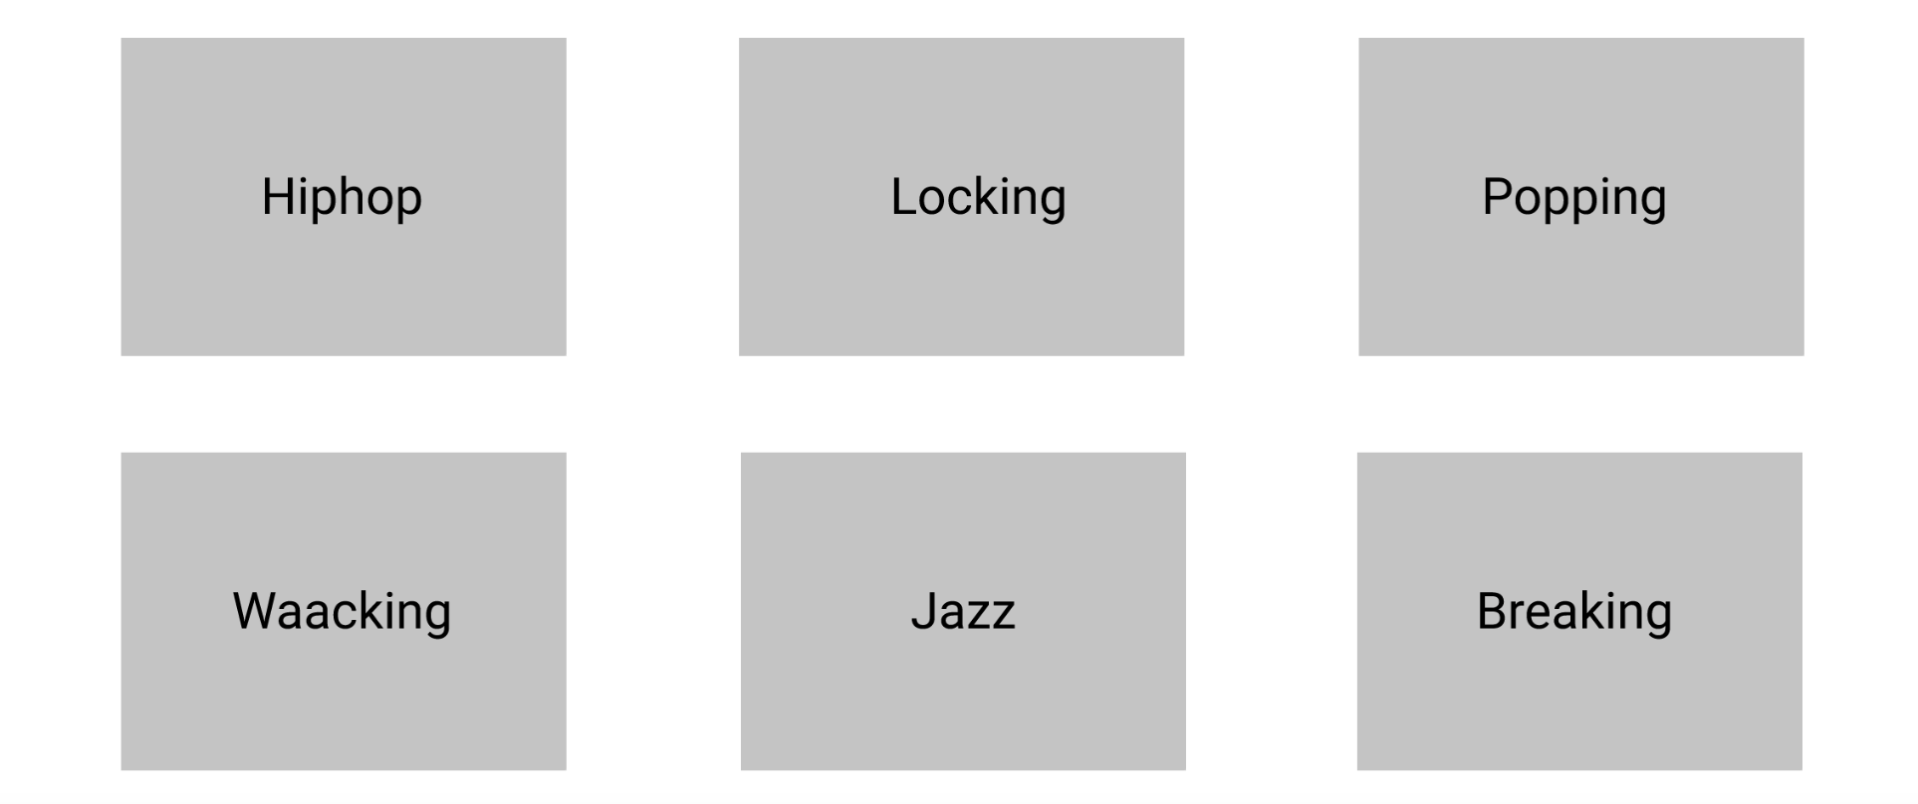 

Figure 7. Figma Layout of Class.



Figure 8. Layout of Competition.

**Test/Evaluation**

Usability

*Test Objectivities:* The projects proposed 3 test objectivities of usability: 1 Do people understand the navigation tab? 2 Is the navigation easy to let users find their way?3 How meaningful to add the signup/login function into the web? 3a. Will people sign up/login for deals? 3b. Is it reasonable to make forced registration to access the content?3c. Do people realize they get discounts to purchase as registered users?

*Tasks of Tests:* The projects made three tasks to test usability.1 Attend one of the competitions you want. 2 Get deals to buy a T-shirt, and tell me how much you will spend? 3 If you're going to take a hip-hop class, find one of hip-hop teachers and tell me his/her dance class schedule.

*Usability Test Reports:* The projects asked six persona students to finish tests and give some feedbacks. Reflecting their performances to the test objectivities, most of them were clear and easy to understand the navigation bar except the “dance”. It was easy to find the way to wanting info since no one made a mistake during tests. They reflected that they would like to register to get the deals. They liked the idea, accessing contents without registration, but they could register later to enjoy the discounts. It gave users freedom. They also reflected that they would not adopt the web if the website was forced to register to see the contents. They were aware of the difference in deals access between unregistered users and members. In sum, the website prototype achieved the three test objectivities except for the confusing “dance” button.

*Design Revision:* They also gave some suggestions on design improvement. One piece of advice was to rename the “dance” button, so it was renamed as “dance class”. The other suggestion was to simplify the navigation bar. It was long. Thus, the project decided to delete signup, log out, and about us. The web moved the about us content to “Alwaysonbeat”, and it split the about us content and home content by reusing the home page. Moreover, it added the signup button on the home page (See Figure 9). Users also can access sign up from log in page. The log out will show up and replace the log in after logging in. For convenience, the website also added the redirect functions to teachers’ IG pages by clicking the IGs and pictures of teachers. Also, on the competition and workshop page, the map function was added to visualize the location of events. The website maintained other designs except the above mentioned.

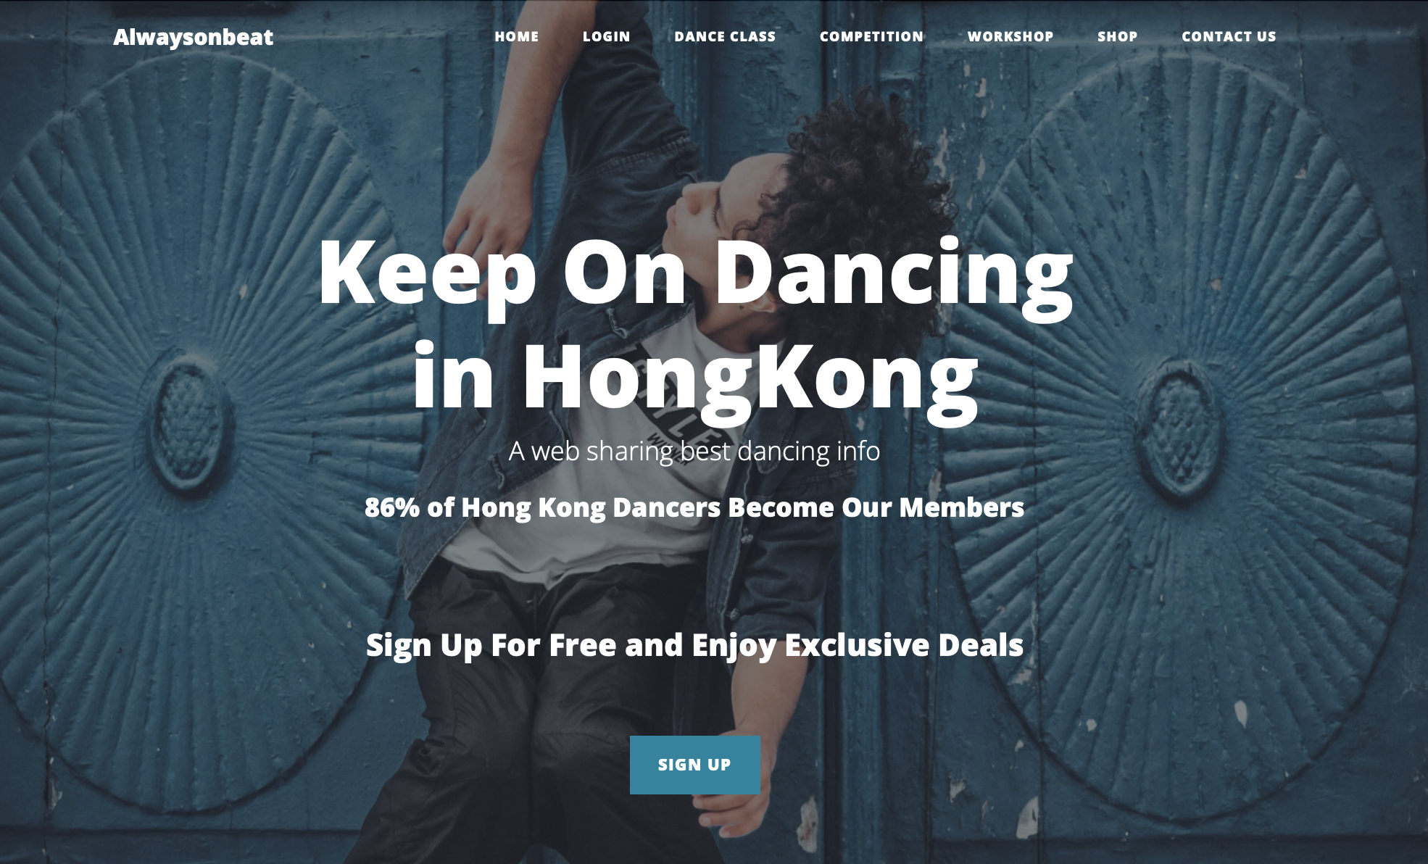

Figure 9. Final Version of porotype

Google Tracking

*Google Optimize A/B Tests Results:* For the A/B test, the project made one variant on “Dance Class” because it was the most confusing point in the previous usability test. The original is called “Dance Class”, and the variant is called “Class”, to see which is better. The test measured bounce rate as the primary objective. It refers to the percentage of users who enter the site and then leave without other actions. According to the results, the google optimize reflected that “dance class” has 96% probability to be the best. The original one has 79 experiment sessions, with six bounces and 7.59% bounce rate, while the variant has 104 experiment sessions, with 18 bounces and 17.31% bounce rate (See Figure 10). The "dance class" has a lower bounce rate, so the website is suggested to maintain the “Dance Class”.

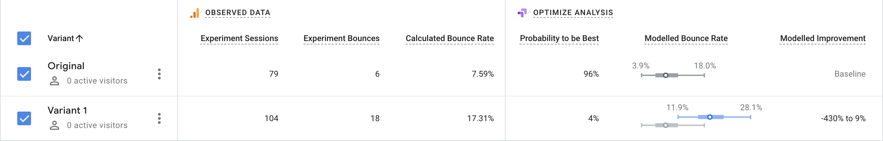

Figure 10. A/B test results, Data Collected on December 7th. Might be silently different from right now

*Google Analytics Page views:* Based on the report, the bounce rate of page views was considerately high. However, it could be inaccurate since the projects kept open and refresh the website for testing purposes at the beginning of the google tracking. It could be a reason to affect the results. If looking at the page session, we can see classes and competitions had more views than others. Popping and Hip-hop received more views than other dance types (See Figure 11).

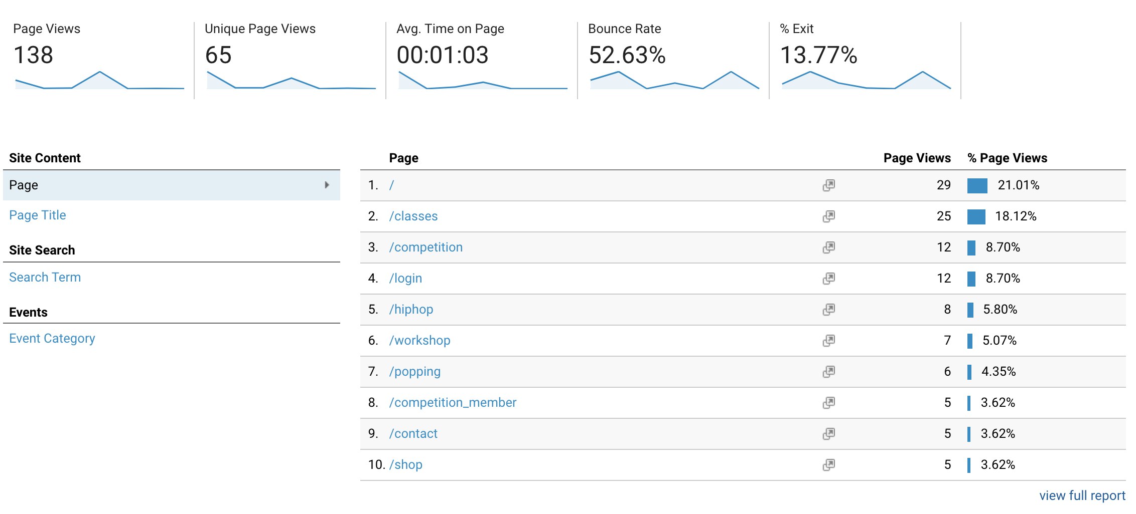

Figure 11. Page Views, Data Collected on December 7th. Might be silently different from right now.

*Google tag manager – Event Tracking:* The website made five event trackings on Google Tag Manager. We can see that competition has the highest number of clicks, and the following are dance class, workshop, shop, and login (See Figure 12). Since it measured actions done by users, we can presume the competition is the most interesting to them. However, there were fewer people clicking login. If we look at the event flow (See Figure 13), Some sessions made 4 events, and most of the sessions lasted to the second or third events. No event was log in in the event flow. Thus, the project should consider why it did not lead to login conversion. It might refer the membership of enjoying the discount or the contents themselves were not attractive to them. For example, users dislike the shirt, and they don’t want to buy it, so they don’t register and log in.

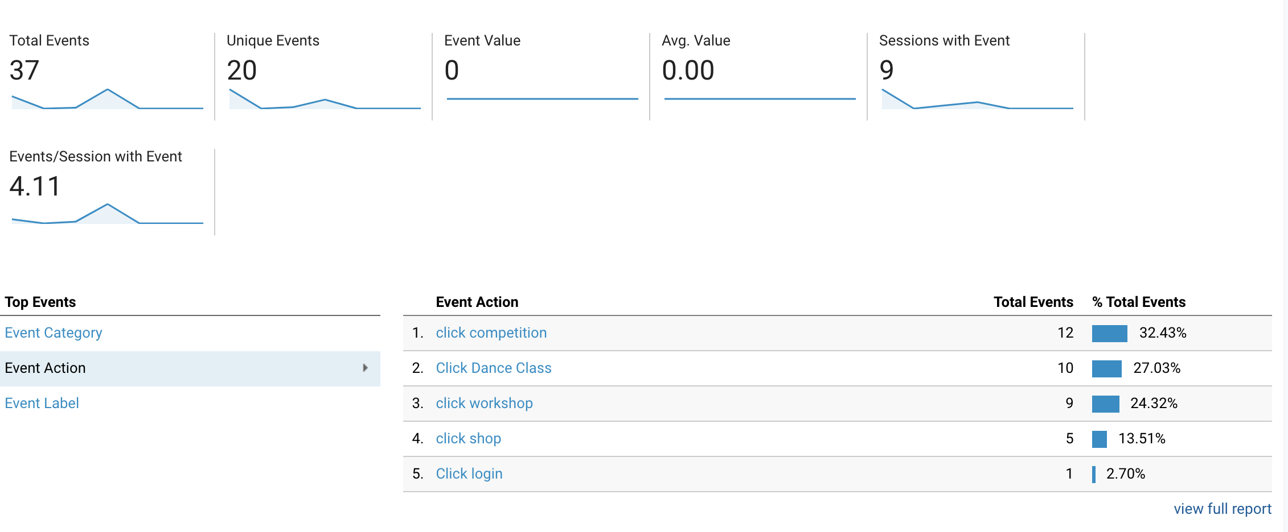

Figure 12. Event tracking results, Data Collected on December 7th. Might be silently different from right now.

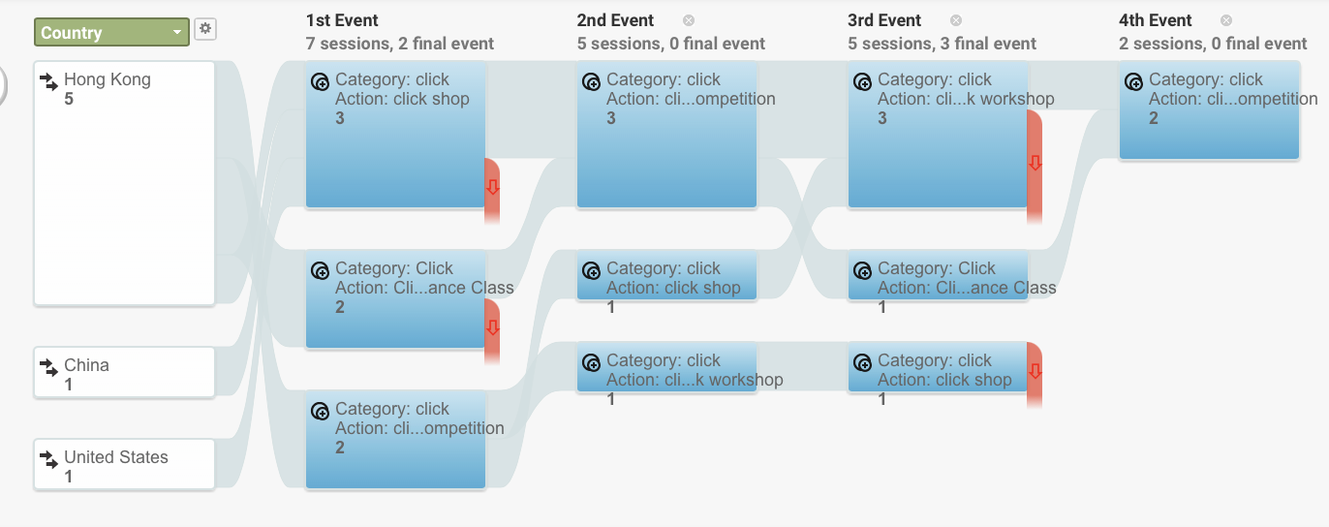

Figure 13. Event Flows, Data Collected on December 7th. Might be silently different from right now.

Database Registered Users

10 people registered. The website did not convert many people to register (See Figure 14).

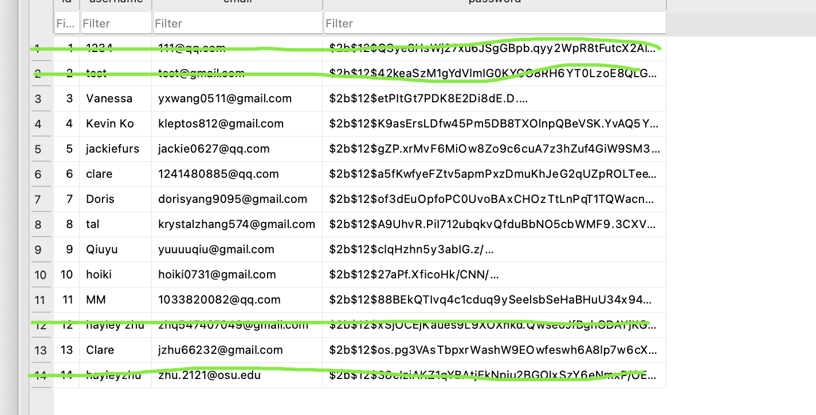

Figure 14 Registration Record on Database. Data Collected on December 7th. Might be silently different from right now.

Recommendations (Market Studies & Further development)

*Attractive Content:* Based on a low amount of login click actions and registered users on the database, the website should consider whether the contents relative to login actions are attractive enough to the persona. the contents refer to competition, workshop, and shop. However, we cannot adjust the contents of competitions and workshops since the website is just a porter of the latest information and provides some discounts. The website does have the right to decide what kind of shirts can be posted by negotiating with other accessories makers. Also, compared with competition, class, and workshop, the shop received fewer clicks. In fact, the project only knew persona like buying dance shirts, but the projects did not go deep enough to look at persona’s flavors, such as genres and colors. For example, do they like school dance society shirts or dance studio shirts? This is the question that should be involved to know better persona’s flavor to target them better. In this way, more market studies about clothing preferences and dressing popularity should be proposed in further development.

*User Community:* The website currently offers information services to consumers, and it is a one-way direction. The website generates information for users. Is it possible to make users generate content? Register users can post and comment in the forum, and the website allows registered users to interact with others. Might finding dance buddies or knowing more dance friends to be another need or pain point to persona? If so, adding the forum community might be a way to improve the website's functionality. However, the project needs to testify whether the demand exists to determine the implantation of the function. Thus, further market studies should do some survey about the dance socialization demand. Moreover, it should explore more persona's pain points to develop the website to fulfill more needs.

*Redo Google Test:* The google test results were not expected. The project did not do an excellent job at manipulation. During the testing period, the administrator kept clicking and viewing the website for test and correction, which affected the google tracking results to a certain extent. Therefore, the current outcomes might not make a precise reference to the actual situation of the website. It is suggested that google tracking should be redone once with strict manipulation by ensuring that everything on the website is good before releasing.

*Explore potential business sustainability:* Could clubs or rental places be suppliers of the website? The project found out a lot of dance events such as competitions and workshops were sponsored by rental places and clubs, by offering free places and drinks. In other words, they are suppliers of the website’s suppliers, and it can be predicted that they also need promotion due to their behaviors of sponsorships. Indeed, dancers love alcohol and dance parties. For further business exploration, the project should try to contact them, to see whether there are chances for business cooperation, such as posts that if people register dance events on the website, then get club coupons. In this way, it brings the traffics each other and boosts the sales of dance events and clubs as well.